**Web Page Hosting on Docker Container using AWS**

In this Project I deploy the static website in docker container using AWS Instance

Technologies Used - Docker, AWS-EC2, Apache2, Git & Github.

***All Steps in details with Commands:-***

**AWS EC2 Instance**

* Click on EC2 service

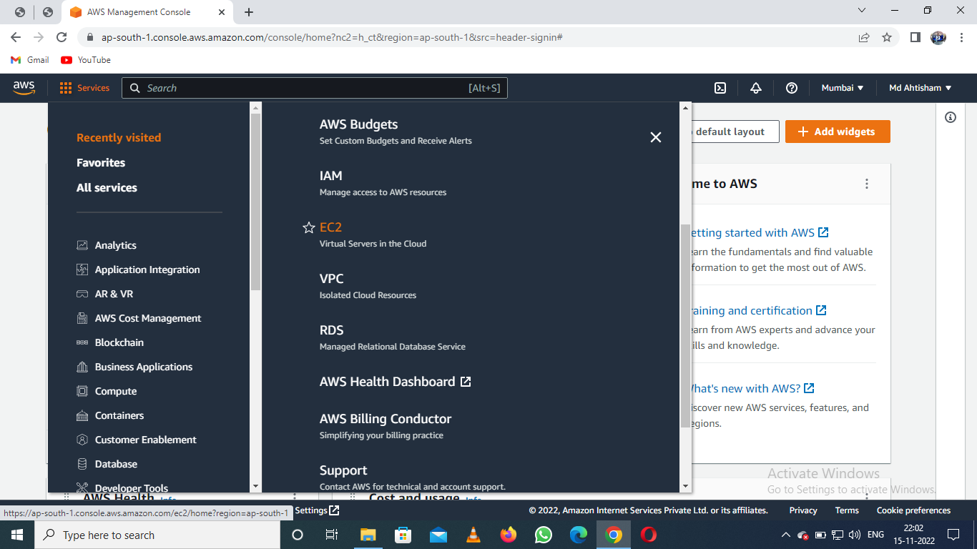

* Click on the Launch Instance

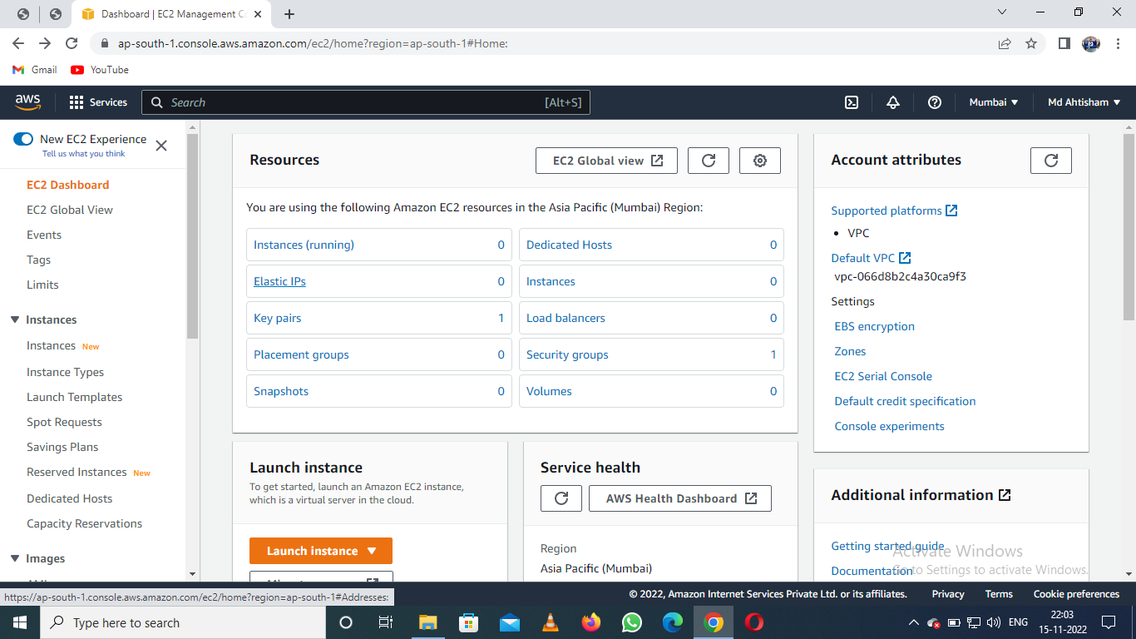

* Name and tags

Webserver

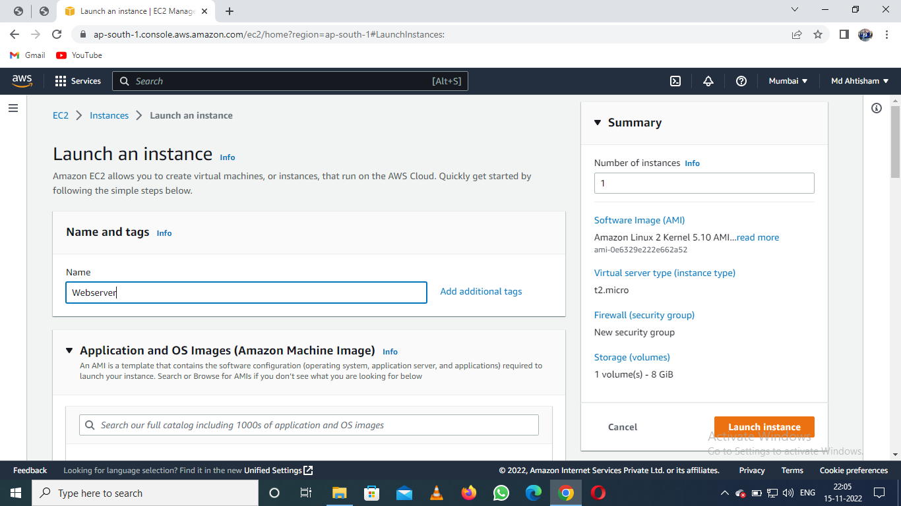

* Choose an Amazon Machine image

Amazonlinux

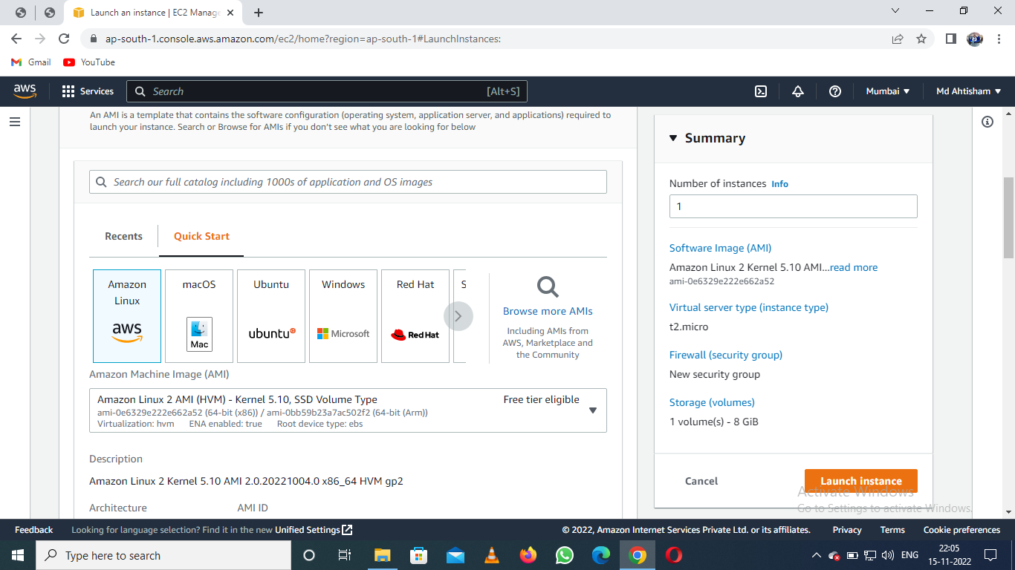

* Instance Type

t2.micro

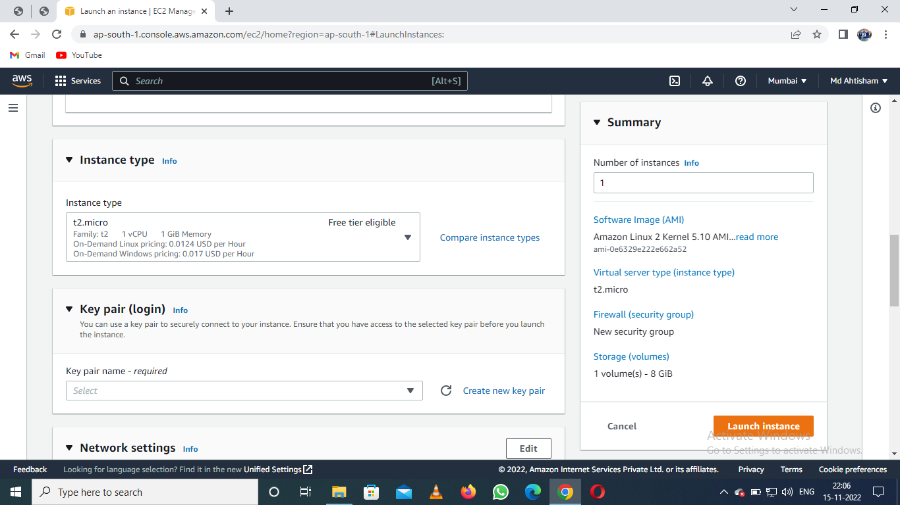

* Create a new Key Pair and Type Name

linux1

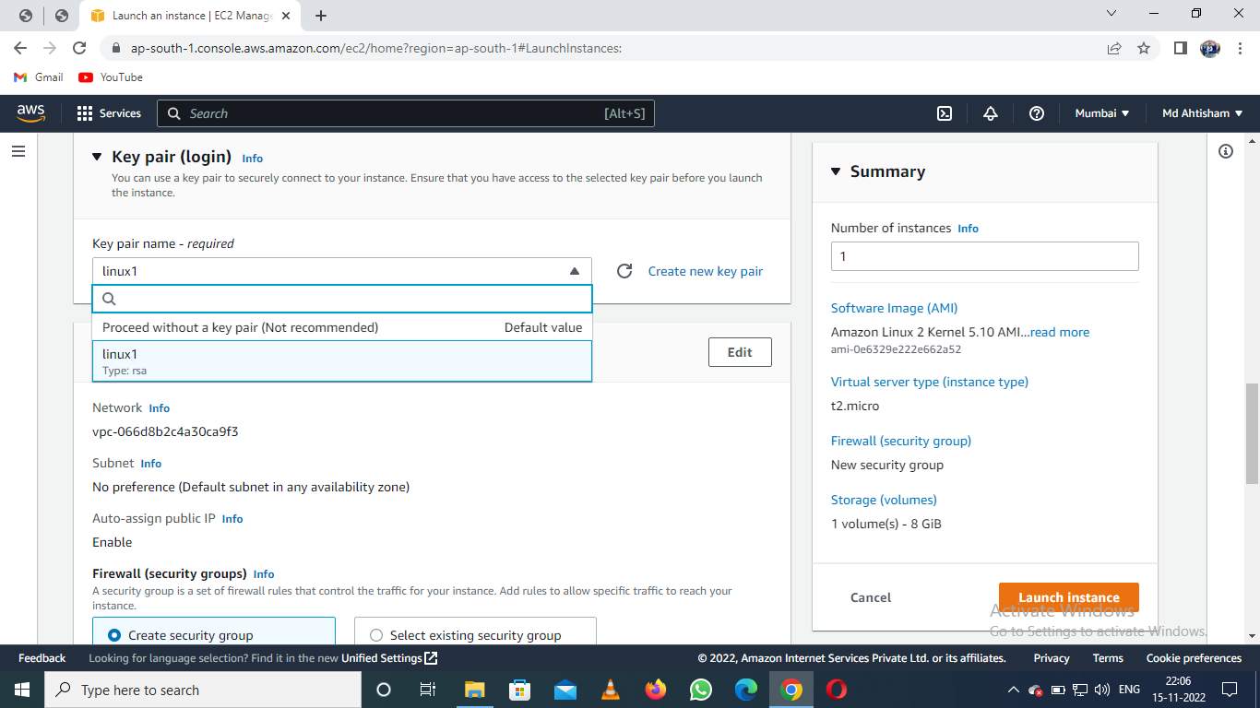

* Create the Security Group

Select - Create a new security group

Security group name = sg-webserver

*Allow HTTPS or HTTP traffic from the internet*

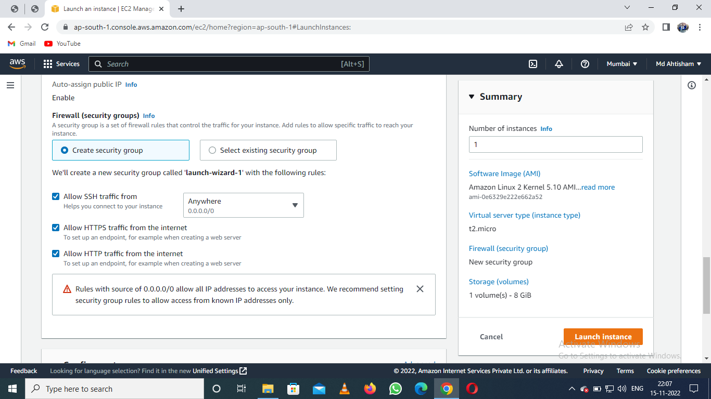

* Configure the Storage

8 GB - Default Root Volume

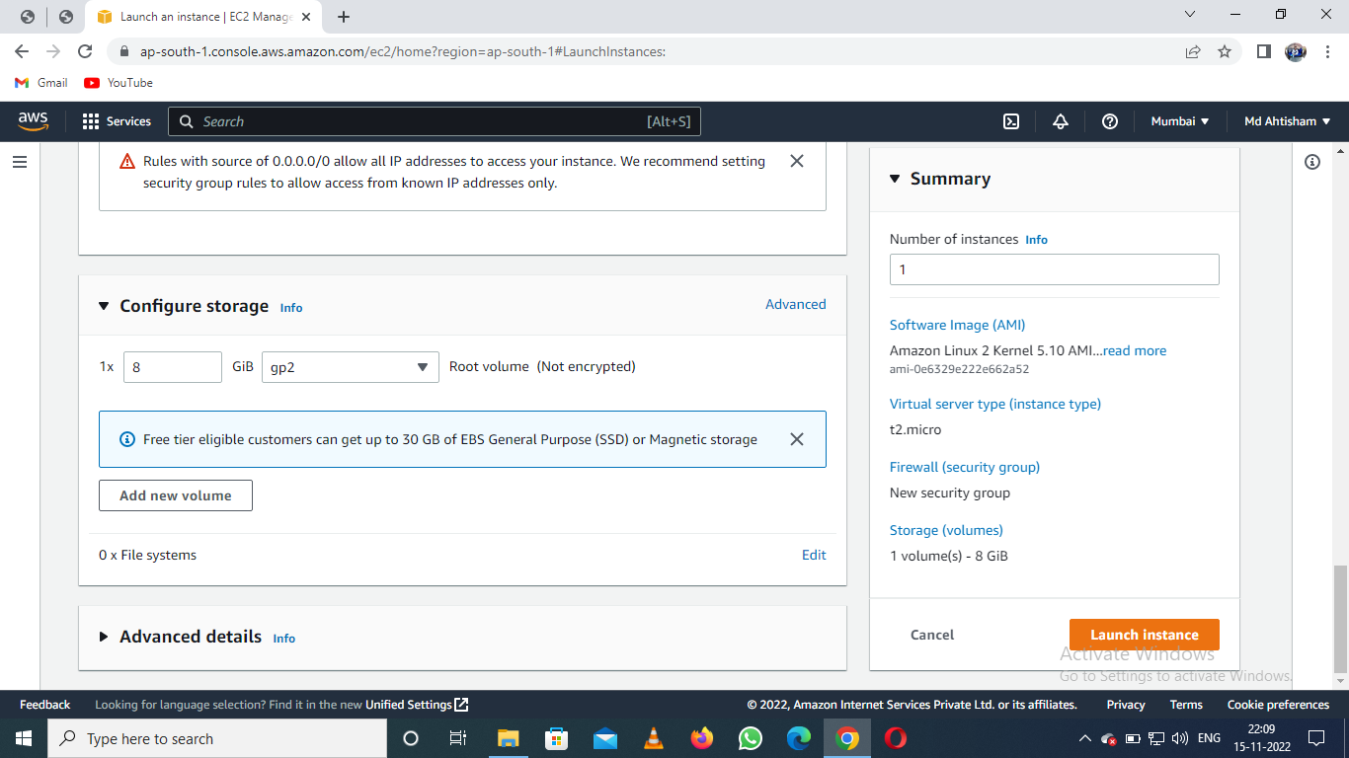

* Click on Launch Instance

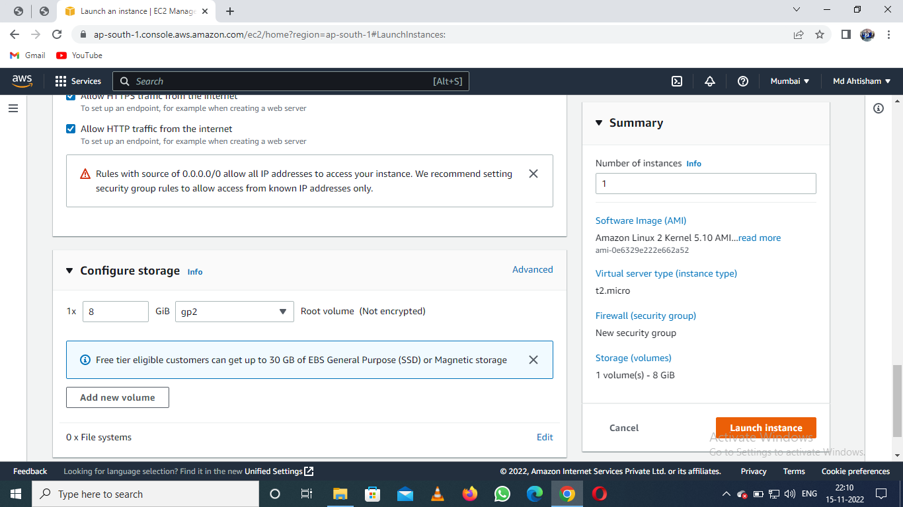

* Access the amazonlinux ec2-instance

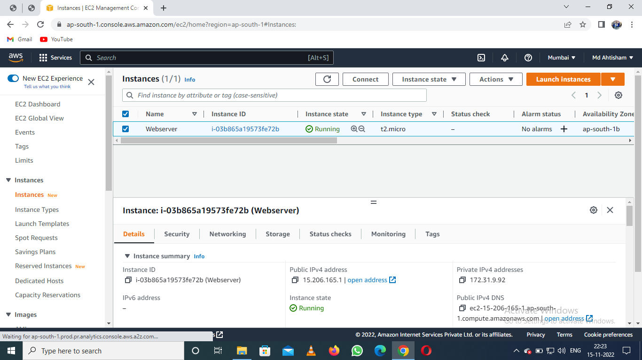

**EC2 - Amazon Linux Instance**

* Command for root access

$ sudo su

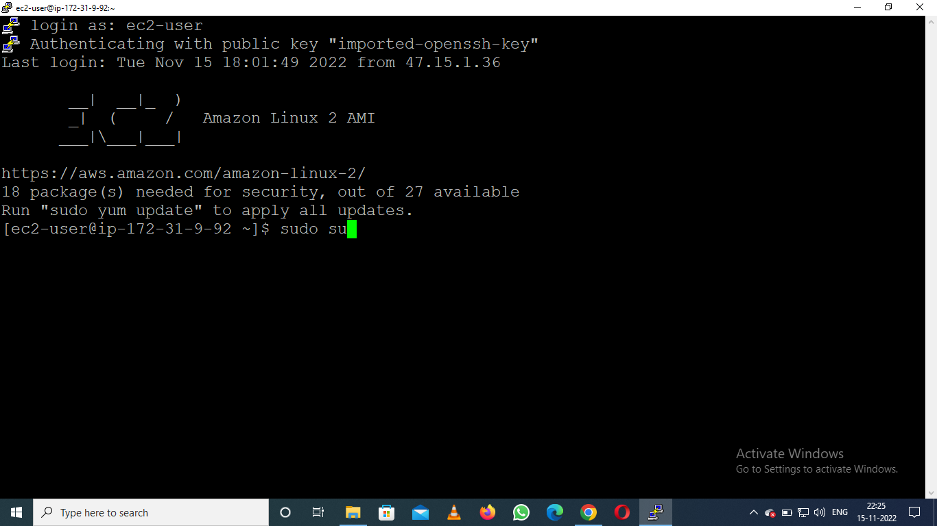

* Update amazonlinux instance

# yum update –y

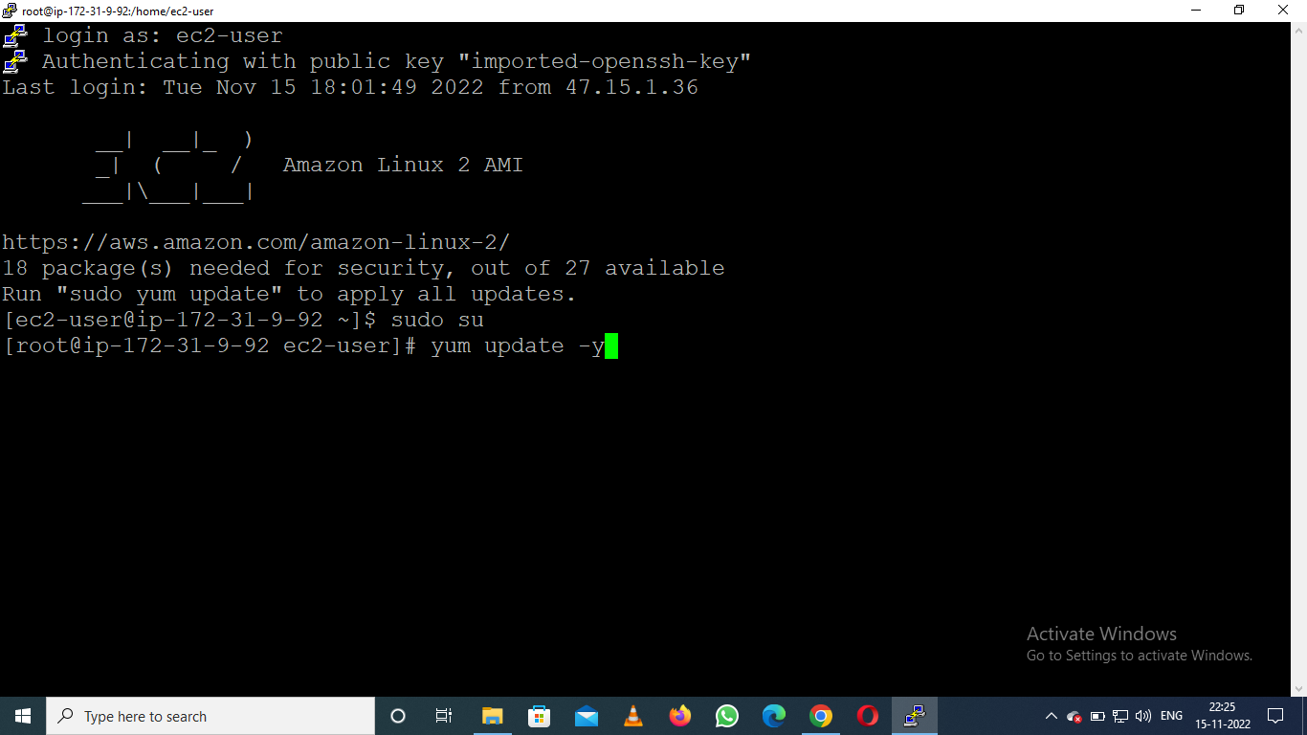

* Install the Docker

# yum install docker –y

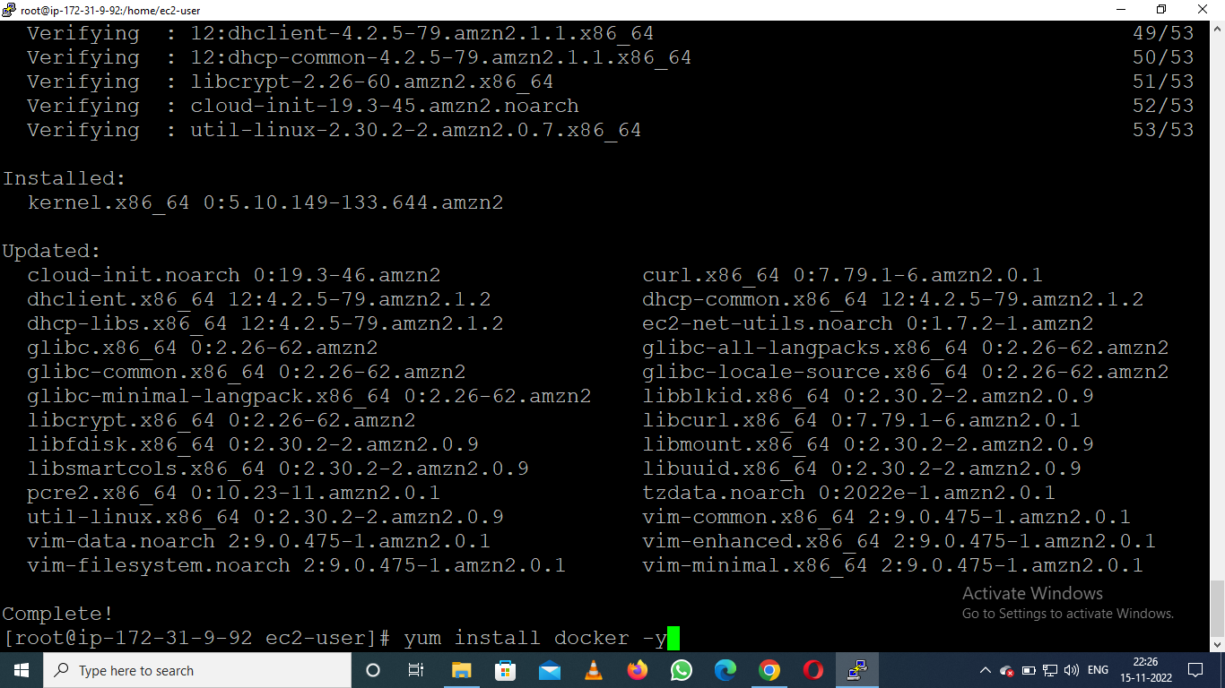

* Check the Docker version

# docker –version

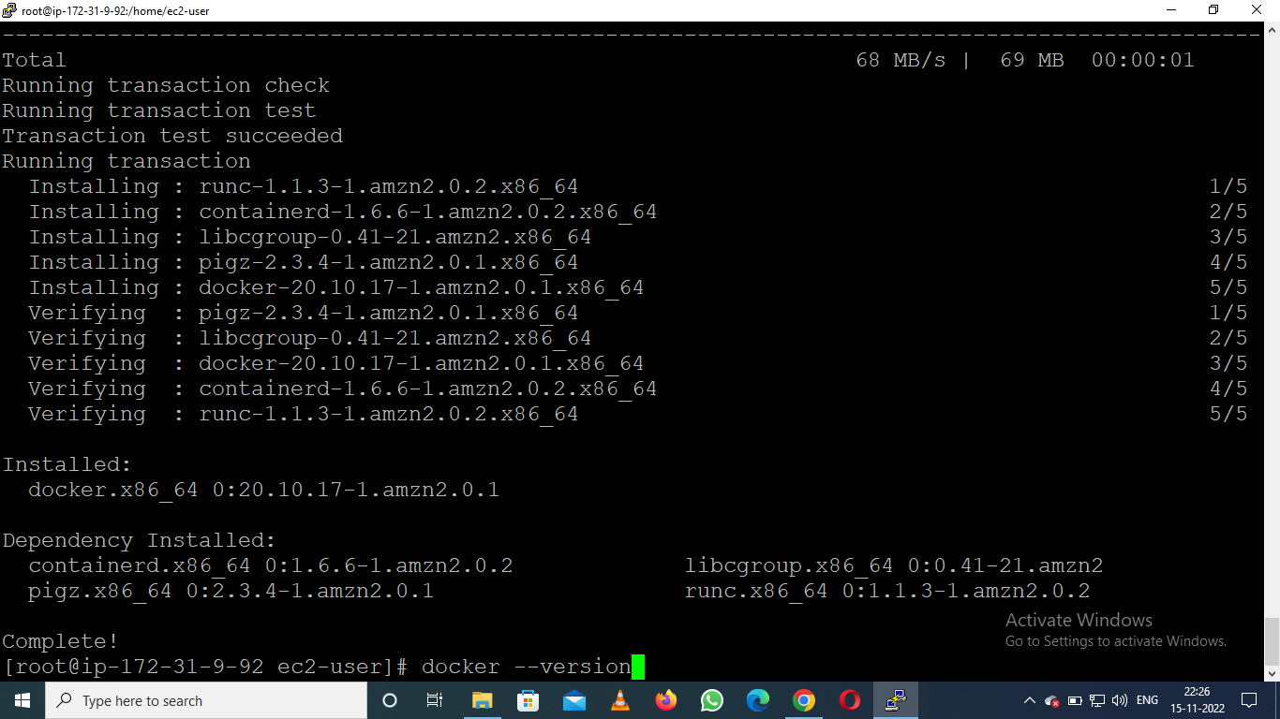

* Start the docker service

# service docker start

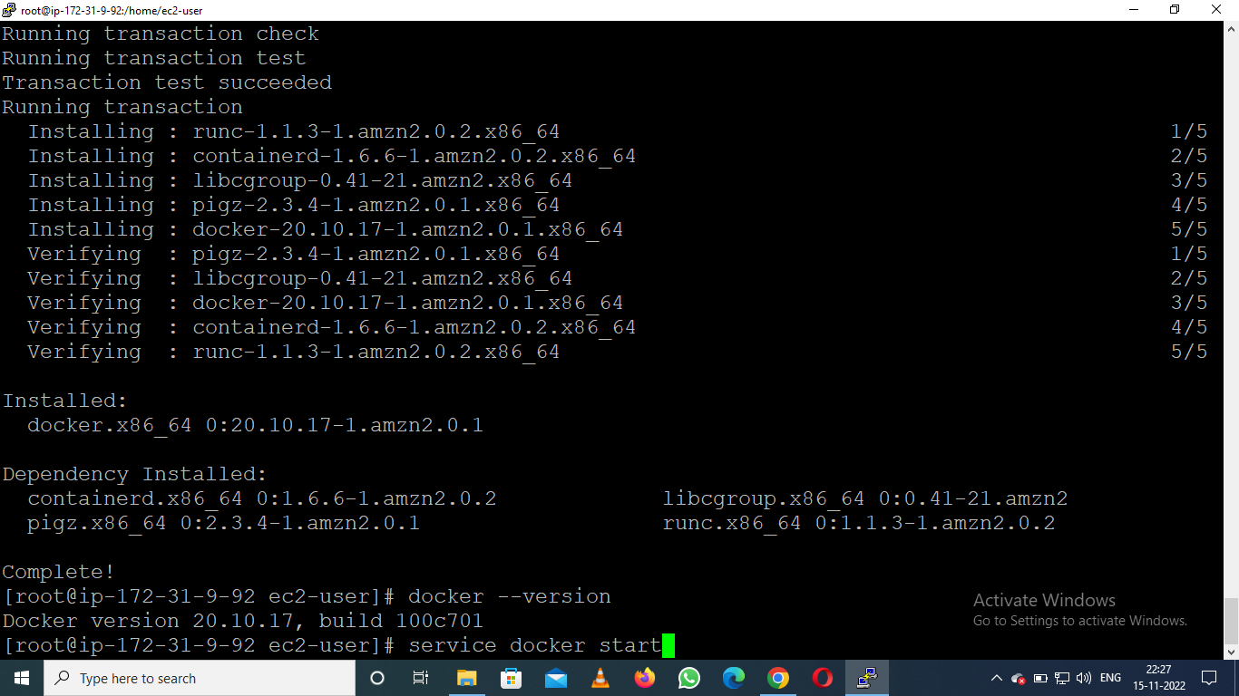

* Check docker service status active or still inactive

# service docker status

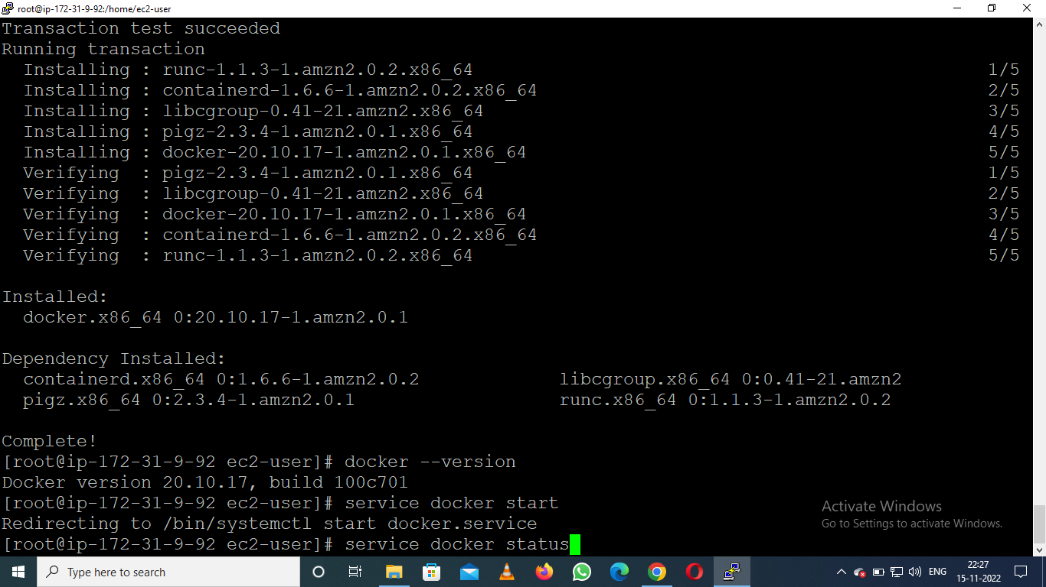

* Search the AmazonLinux Image from Docker Hub

# docker search amazonlinux

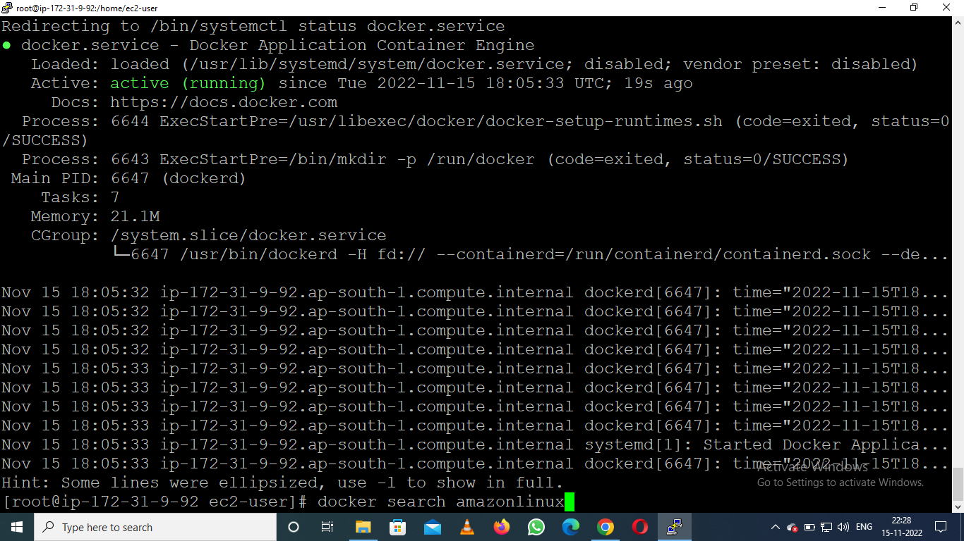

* Pull Images

# docker pull amazonlinux

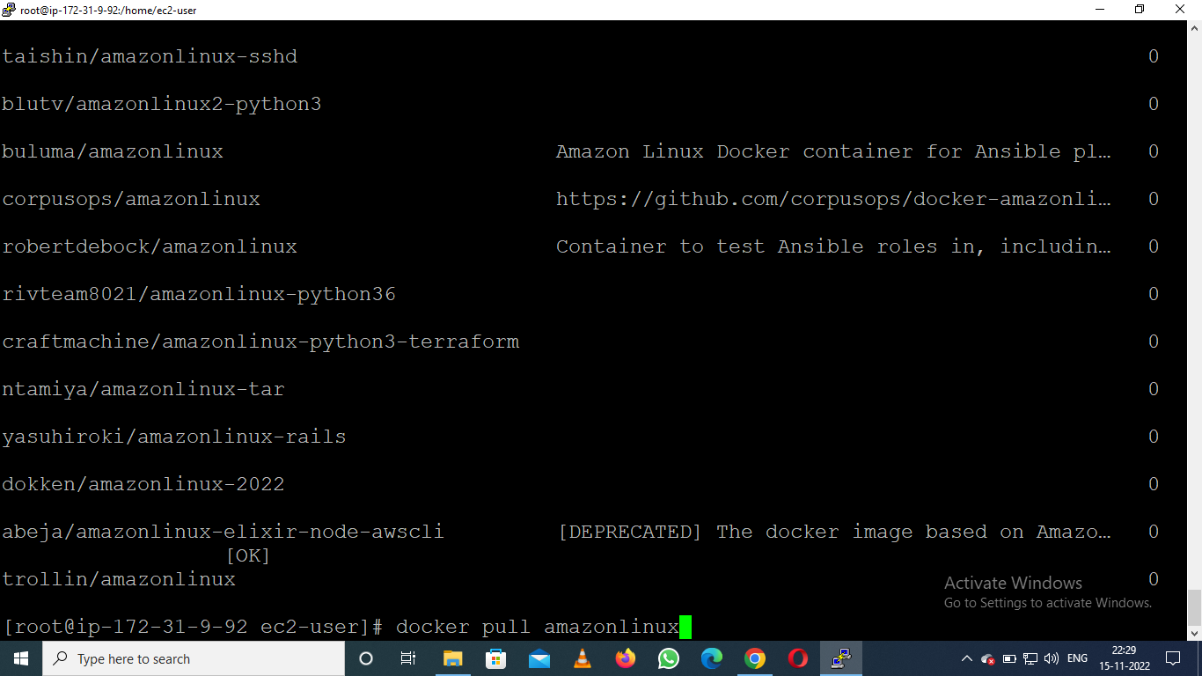

* Check the Images

# docker images

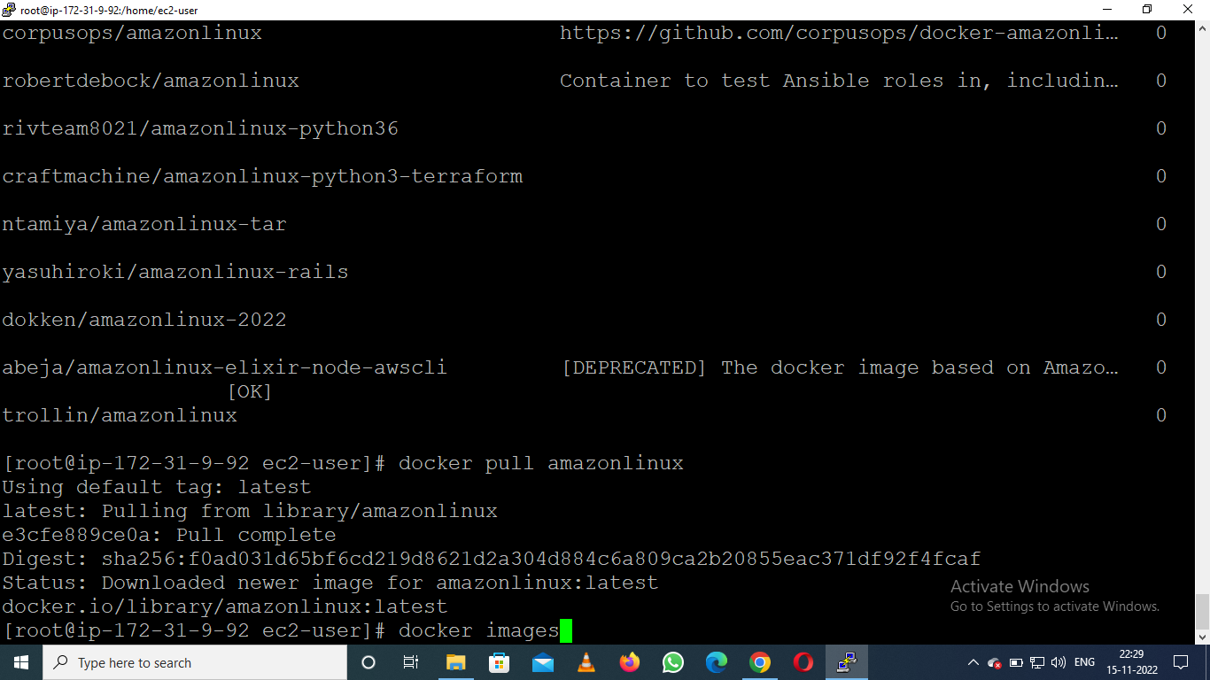

* Run the container with existence image and expose the port 80

# docker run -td --name webserver -p 80:80 amazonlinux

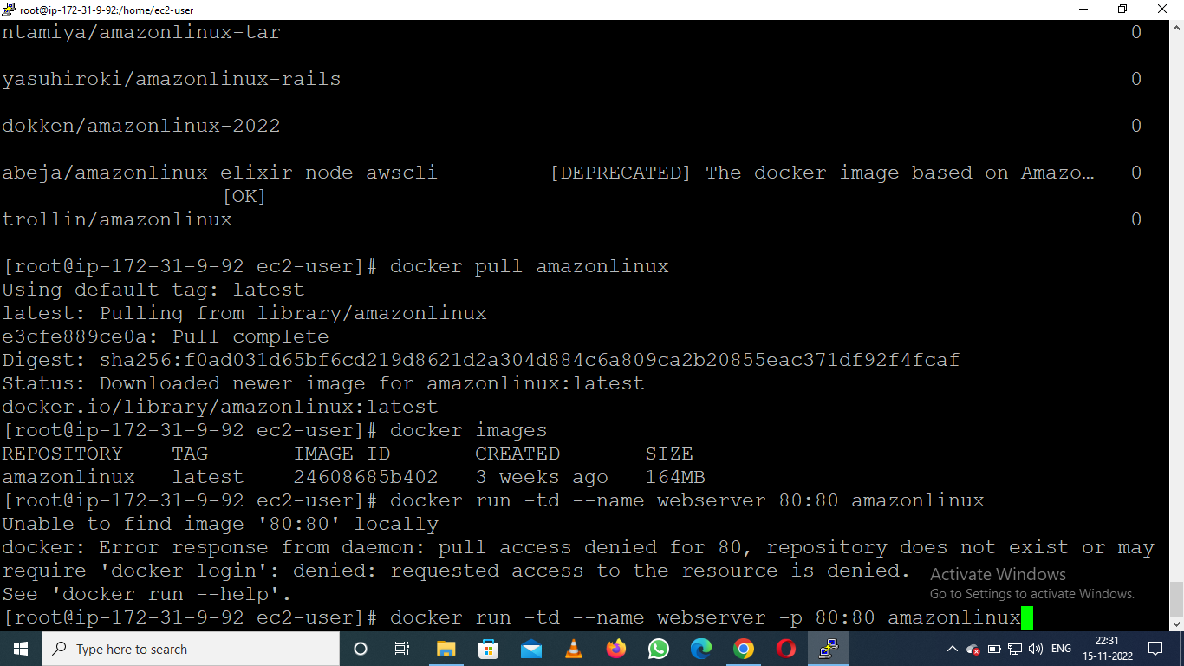

* Check the port is open or not

# docker port webserver

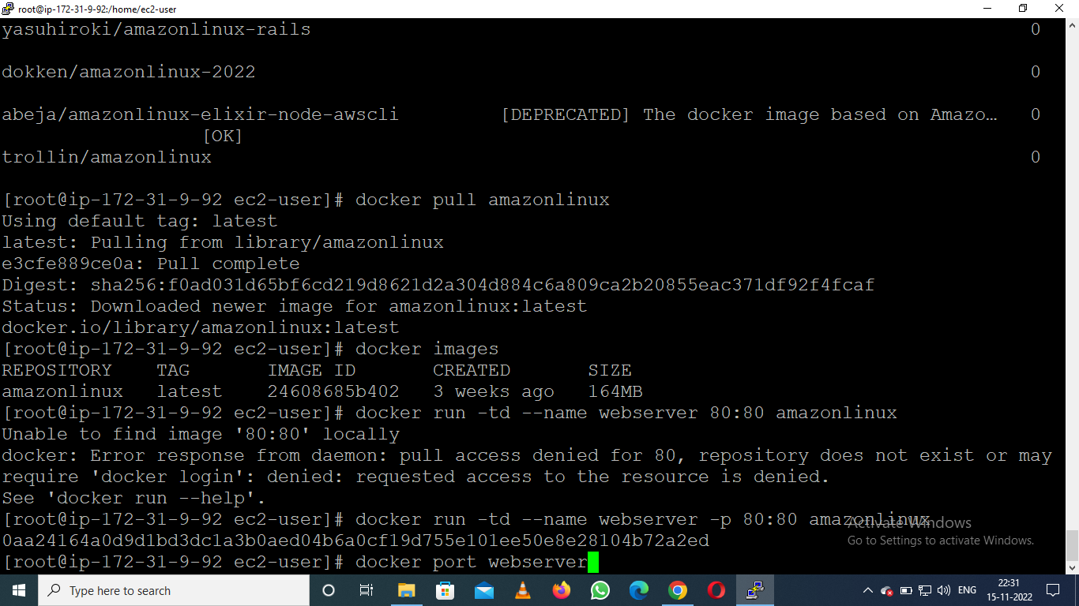

* Execute the Command

# docker exec -it webserver /bin/bash

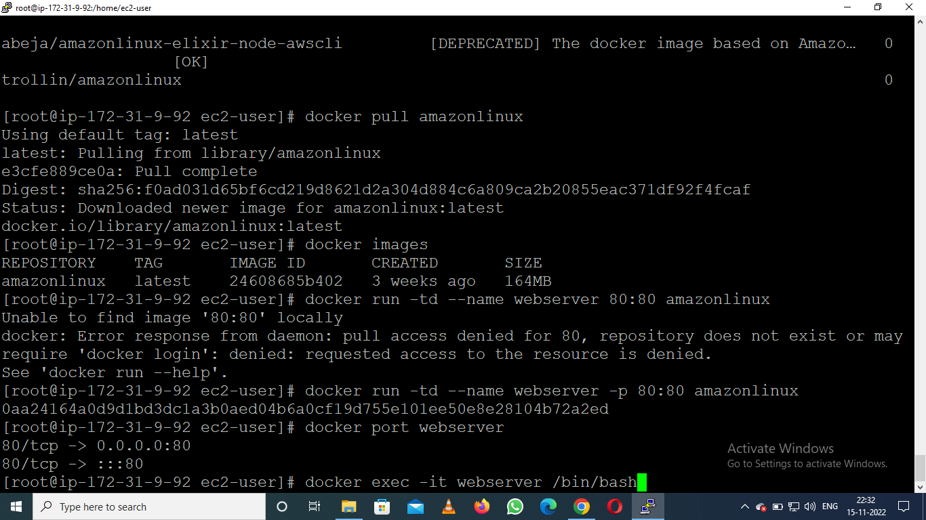

### *****Now you will enter into the Docker container Terminal*****

## Docker Container Terminal

* Update the container

# yum update –y

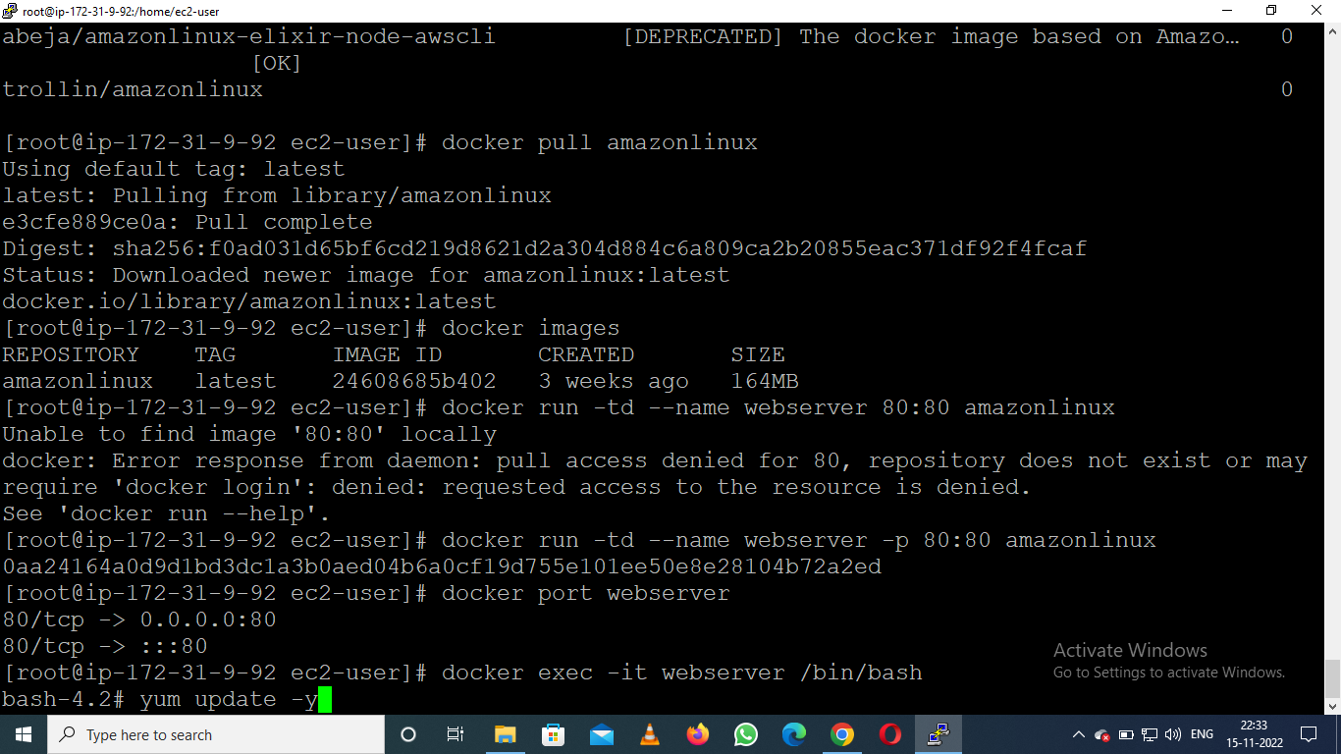

* Install the Apache2 web server

# yum install httpd –y

* Open the html directory for deploy the html(index.html) file

# cd var/www/html

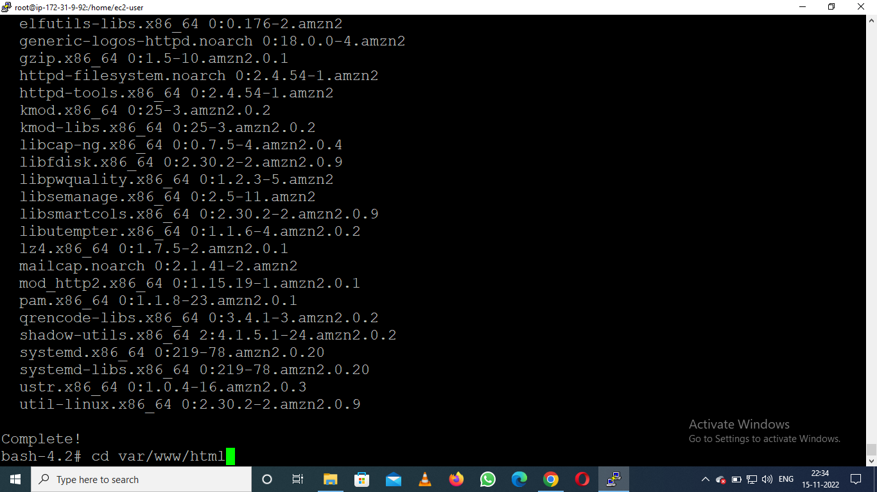

* Run these command for configuration

# /usr/sbin/httpd

# vi /root/.bashrc --- press "esc key" --> :wq --> "enter key"

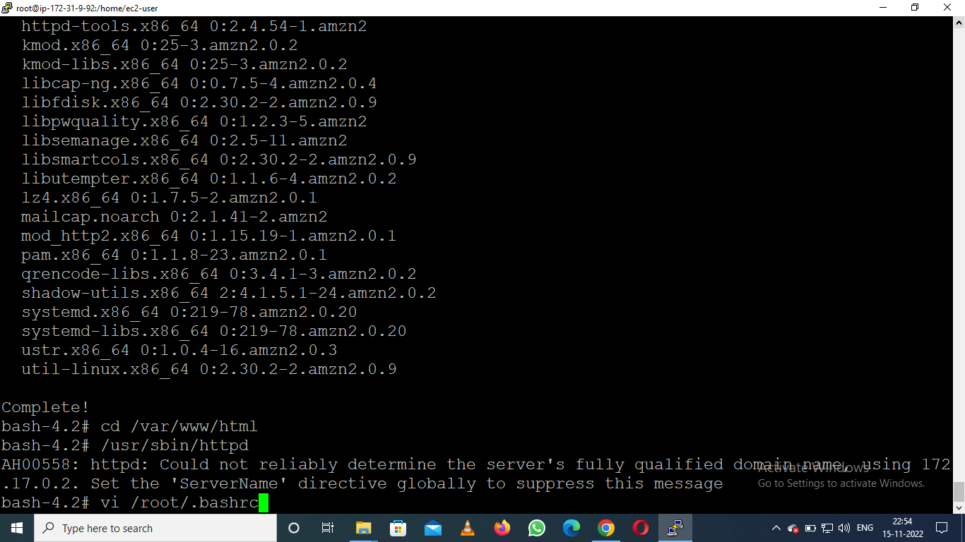

* Create the index.html file in html directory

# vi index.html

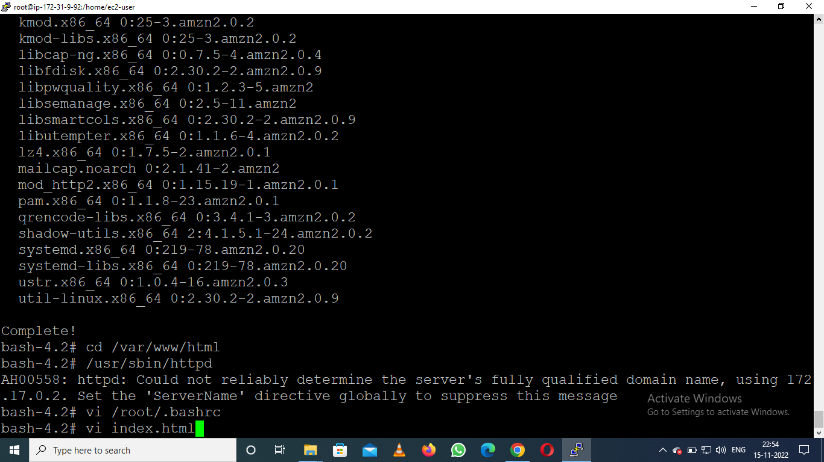

* Deploy your code in HTML File
* Copy the IP Address from AWS EC2 Instance

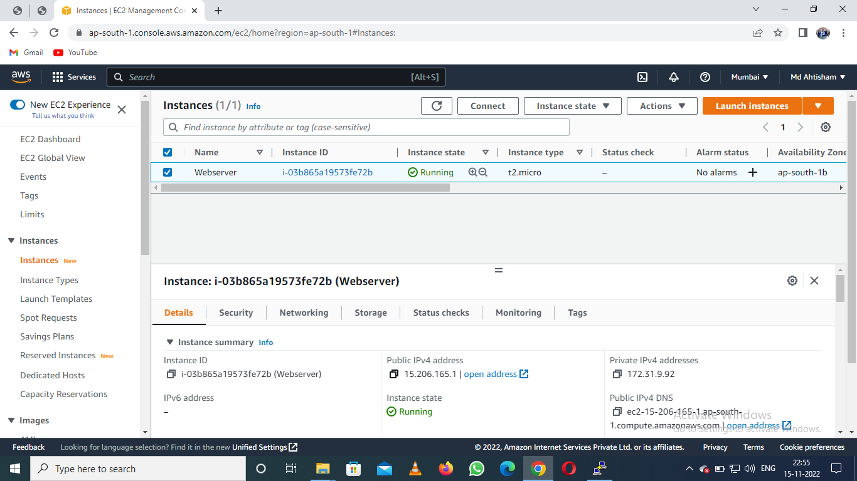

* Paste the IP Address in Browser URL

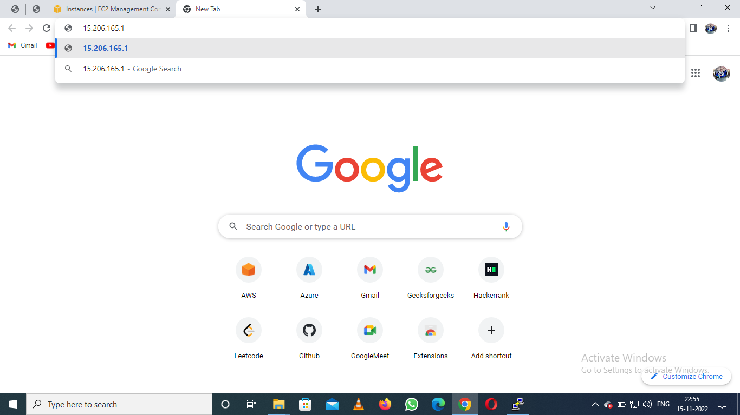

* Now we can see the website is hosted in Docker container

